# Allocation of Resources during COVID-19 pandemic

## *Executive summary*

## Introduction

The COVID-19 pandemic has now reached The Gambia. It is likely that there will be a huge demand on health systems, public health and clinical services and it may be that these demands cannot be fully met. Therefore medical equipment, beds and interventions may need to be rationed. Under these circumstances, rationing is not a choice, but a necessity due to the overwhelming effects of a pandemic.

A multi-value ethical framework should be used to make decisions on resource allocation based on the following principles:

* Maximising the benefits produced by scarce resources
* Ensure fair & equitable care
* Be responsive to evidence
* Prioritise the care of health workers
* Apply the same principles and equitable health care to all COVID-19 and non-COVID-19 patients

In addition, decisions around rationing of resources should be transparent, reasonable for The Gambian context and be taken with patients and their views in mind (inclusive). Accountability should be embedded within the framework, with measures to ensure that ethical decision making is sustained throughout the pandemic and that doctors and health workers are still held accountable for their decisions, as per normal practice. Furthermore there should be support for healthcare workers whose mental health may be jeopardized by being forced to make very difficult decisions for their patients.

## Target user

* Nurses
* Doctors

## Target area of use

* Outpatient department
* Ward

## Key areas of focus / New additions / Changes

This guideline deals with allocation of resources to patients in the context of a COVID-19 pandemic, acknowledging that those sick from other causes will also suffer the consequences of an overloaded health system. The guideline does not cover the allocation of Personal Protective Equipment (PPE) for clinical staff.

## Limitations

Treatment of COVID-19 patients in this setting are already limited by restricted access to ventilation or intensive care support. Language barriers may pose a challenge to effective communication with patients and families.

## Maximising the benefits

This is the most important consideration. This means prioritising saving the most lives and the most life-years. In practice, it means focusing resources on those most likely to survive the longest after treatment.

Based on evidence from China of 72,314 cases, there were no deaths in the mild or severe cases. Critical cases had a case fatality rate of 49%.

Case fatality rate reported by age:

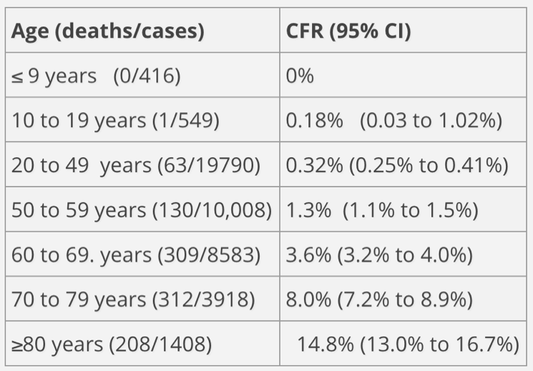

Case fatality rate reported by co-morbidity:

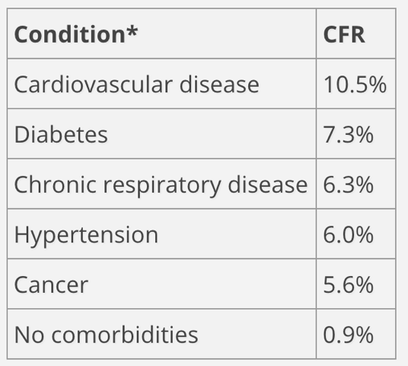

In our setting where there are no critical care facilities, those with critical disease unresponsive to available respiratory support should be provided symptomatic treatment only.

Rationing of oxygen and other supportive treatment for severe cases should consider the likely prognosis to help guide decision making. Patients may move from severe to critical, recognition of this and withdrawal of scarce resources from an individual patient with a poor prognosis and limited response to management may be needed to enable another patient an opportunity to benefit from scarce resources.

## Prioritise Health Workers

COVID-19 testing and treatment should prioritise the front-line health care workers and those who keep the critical infrastructure running (key workers). This is because their training and expertise make them essential to the pandemic response.

The MRC clinical services department is mandated to provide healthcare to staff and their immediate family, study participants receiving active follow-up and the general public. These priorities will continue, with the proviso that non-MRCG health workers or key workers will be prioritised within the general public.

## Allocate in a fair and transparent way

Allocation of resources should be in accordance with local and national treatment guidelines. Do not allocate according to wealth, religion, tribe or status. Allocation of resources should be according to recognised co-morbidities and clinical features and be done in a transparent way. Clear pathways for assessment and admission of all patients with COVID-19 or other diagnoses should be followed to promote transparency and avoid discrimination or preferential treatment

For patients with similar prognoses then decisions may be difficult. An objective scoring system in conjunction with consideration on a case-by-case basis by an independent committee will be applied when possible under these circumstances. Fair, consistent and transparent allocation procedures should be used at all times.

## Be responsive to the evidence

As the COVID-19 pandemic grows in The Gambia, local and global evidence should be used to revisit these guidelines and change any aspect of it as is appropriate. There should be flexibility in revising guidelines in response to disputes and complaints.

## Apply the same principles and equitable health care to all COVID-19 and non-COVID-19 patients.

COVID-19 will result in scarcity in resources for all patients, whether they have COVID-19 or not. Therefore the principles applied to allocation of resources should be the same regardless of COVID-19 status. This includes access to investigations, medications and quality of care.

## Rationing of resources in practice:

* Severity / prognostic scores which are suited to the local context should be used to aid rationing decisions whenever possible. This should be objective, transparent and in keeping with the principles outlined above.
* A **treatment escalation plan** should be completed at the time of admission for all patients, taking into account co-morbidities, pre-existing medical conditions, pre-existing do not resuscitate (DNR) intentions and resources available at the time (e.g. level of respiratory support). This should specify the ceiling of care to be delivered to each individual patient. It should also be discussed with the patient and their carer, if possible.
* Regular re-assessment of the clinical condition should be done (and embedded in clinical guidelines) to ensure that as patient’s needs change, there is a system for re-directing or starting care in a timely manner
* Discussions with patients and families about their likely prognosis should be done as soon as possible and in a culturally sensitive way, with the patient and family wishes considered
* Clear documentation of the decision making process is important, with the reasons for any decision clearly set out in writing
* Most patients will have clear cut clinical progress which can be managed through routine pathways
* An independent committee of senior clinicians and nurses alongside ethical input with understanding of the local cultural and medical context should be available to discuss difficult rationing decisions and take the burden of decision making away from treating clinicians
* The literature suggests that caregivers and health workers find rationing resources as described above enormously stressful, such that it may impact on their ability to deliver care. Pastoral and psychological support should be considered for all persons involved in making rationing decisions from the front line staff to independent committee members
* Consider establishing a lay expert group consisting of recovered patients to be patient representatives and give input into development of rationing guidelines and systems

**References / resources**

Ezekiel Emanuel et al. “Fair allocation of scarce medical resources in the time of COVID-19*”. N Engl J Med*. Mar 23, 2020

Zunyou Wu, Jennifer McGoodan. “Characteristics of and important lessons from the Coronavirus disease 2019 (COVID-19) outbreak in China. Summary of a Report of 72 314 cases from the Chinese centre for disease control and prevention”. *JAMA*. Feb 24, 2020

Royal College of Physicians. Ethical dimensions of COVID-19 for frontline staff. 2nd April 2020 <https://www.rcplondon.ac.uk/news/ethical-guidance-published-frontline-staff-dealing-pandemic>

British Medical Association (BMA). COVID-19 Ethical Issues. A guidance note. 3rd April 2020 <https://www.bma.org.uk/media/2226/bma-covid-19-ethics-guidance.pdf>

|  |  |  |
| --- | --- | --- |
| **Written by:** | Name: Ana Bonell & Behzad Nadjm | Date: 28 March 2020 |
| **Reviewed by:** | Name:  MRC Gambia Resource rationing Working Group (H Brotherton, E Clarke, K Forrest, M Cham, H Jah, F Akemokwe, B Kampmann) | Date:  21 May 2020 |
| **Version:** | **Change history:** | **Review due date:** |
| 1.0 | New document | 30 April 2022 |
| Review Comments (*if applicable)* |  |  |

Attachment 01: COVID-19 Advisory Committee Terms of Reference

Attachment 02: COVID-19 Advisory Committee Summary of patient progress

Attachment 03: COVID-19 Advisory Committee Response form